**23CSE111**

**OBJECT ORIENTED PROGRAMMING**

**LAB REPORT**



**Department of Computer Science Engineering**

**Amrita School of Computing**

**Amrita Vishwa Vidyapeetham, Amaravati Campus**

**Name:M.PRANAVI**

**Verified By Roll No: 24302**

**WEEK 01**

**PROGRAM-1:**

**AIM:** Download and Install Java Software

**PROCEDURE:**

**Step 1: Download JDK 21**

1. Open your web browser and go to the Oracle JDK Downloads page
2. Scroll down to the Java SE Development Kit 21 section.
3. Choose the Windows x64 Installer version.
4. Click on Download, then Wait for the download to complete**.**

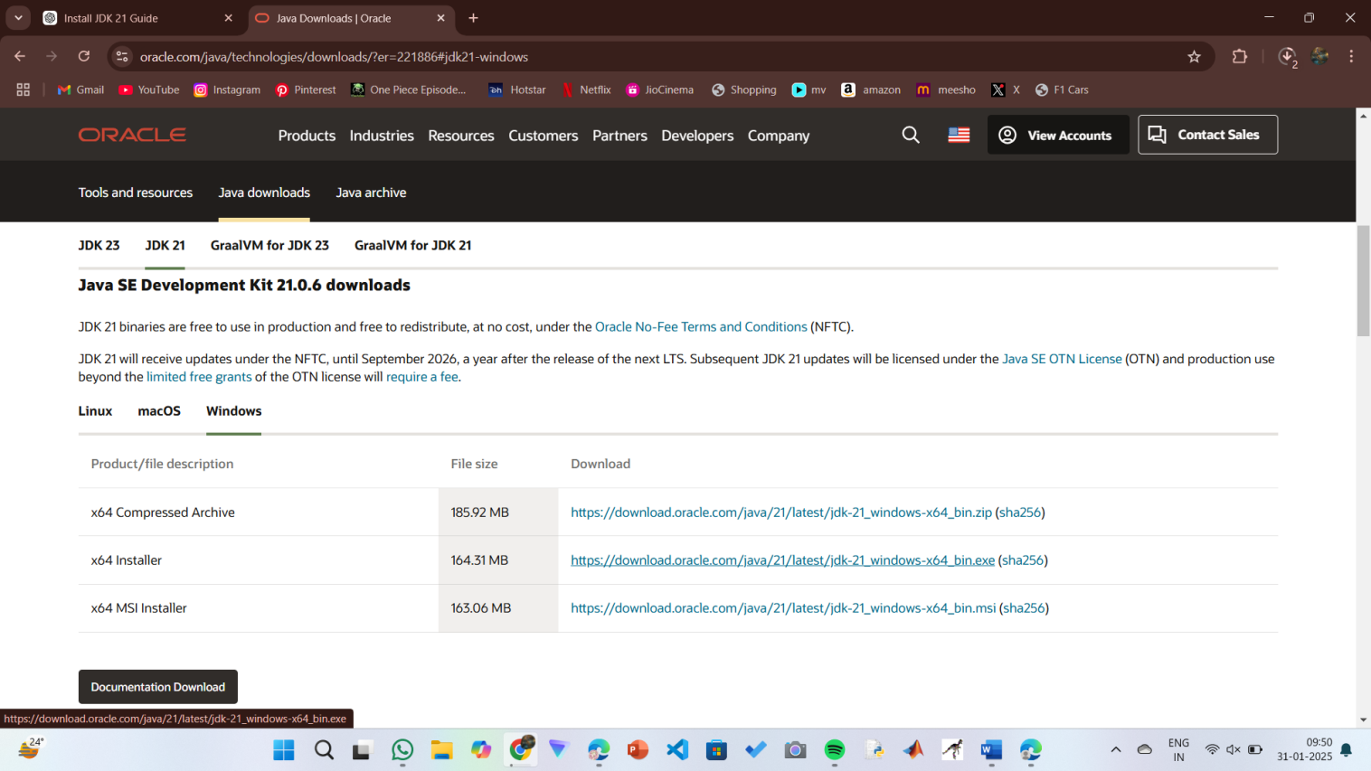

**Step 2:** **Install JDK 21**

1. Locate the downloaded jdk-21_windows-x64_bin.exe file.
2. Double-click to launch the installer.
3. Click Next on the setup wizard.
4. Choose the installation path (default is C:\Program Files\Java\jdk-21).
5. Click Next, then click Install.
6. Wait for the installation to complete.
7. Click Close once the installation is finished.

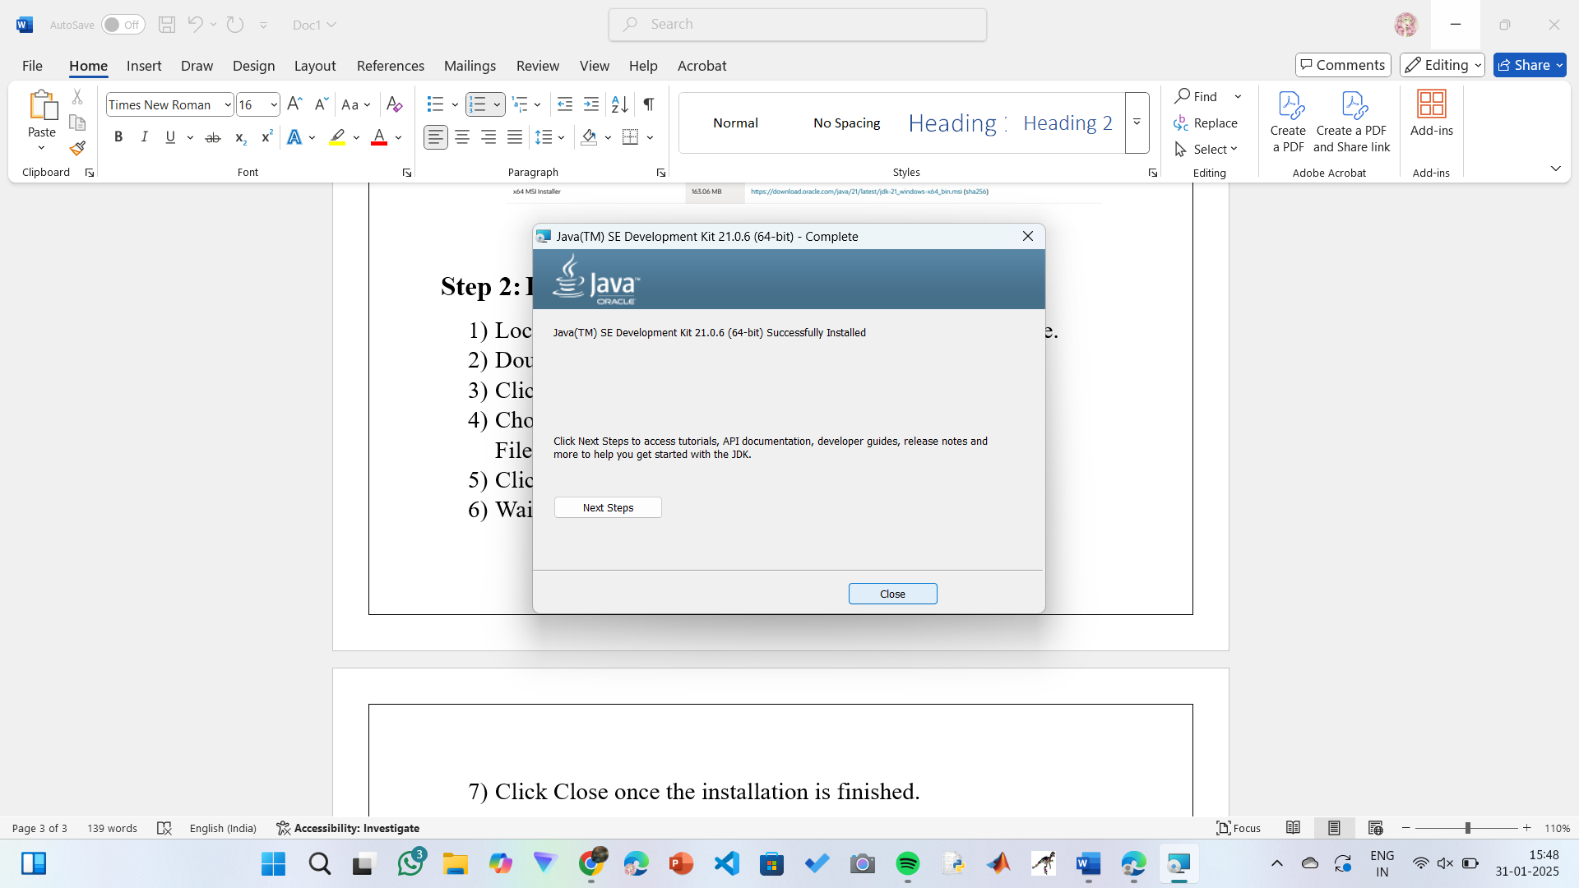

**Step 3: Setting up the path**

1) Go to “Windows C” Drive on Desktop

2) Choose Program Files, select Java, then JDK 21, then select Bin.

3) Select and copy the path at the address bar.

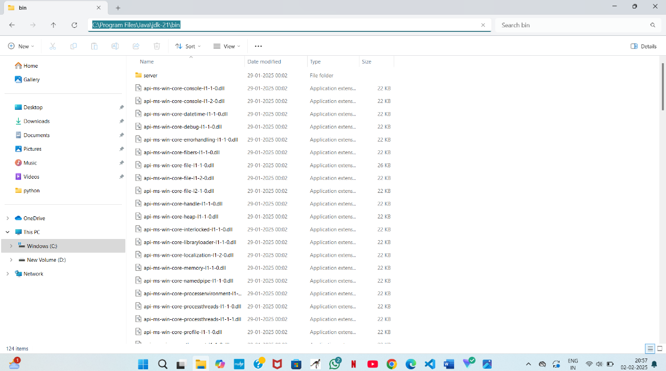

**Step 4: Open System Properties**

1. Press Windows + R, type sysdm.cpl , and click Ok-
2. The System Properties window will open.
3. Navigate to the Advanced tab.
4. Click on Environment Variables at the bottom.

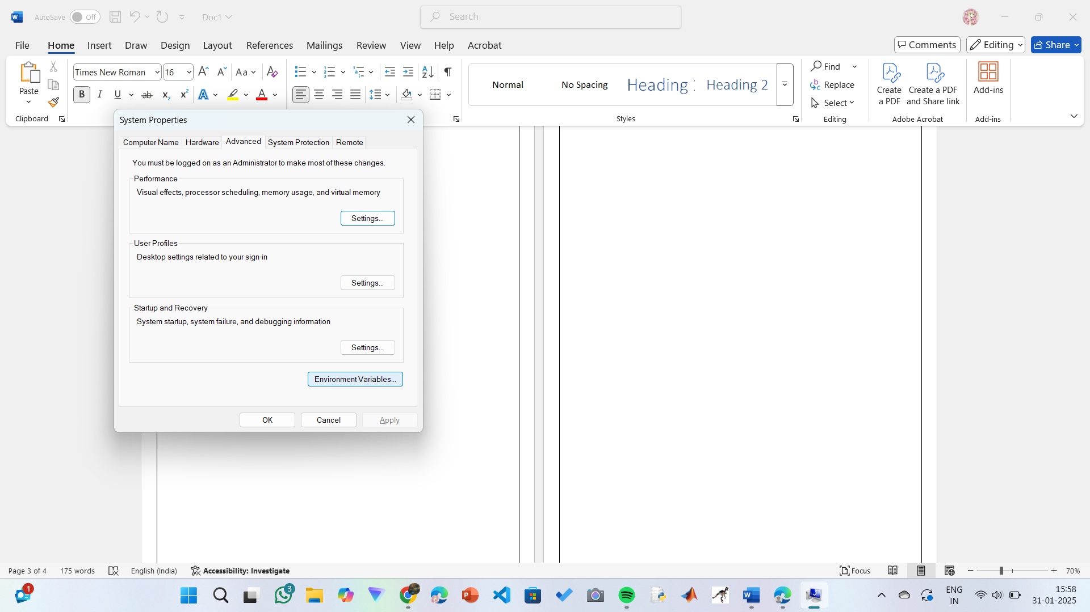

**Step 5: Set JAVA_HOME**

1)Under System Variables, click New.

2)Set the Variable name as JAVA_HOME.

3)Set Variable value as C:\Program Files\Java\jdk-21 (or your installation path).

4)Click OK.

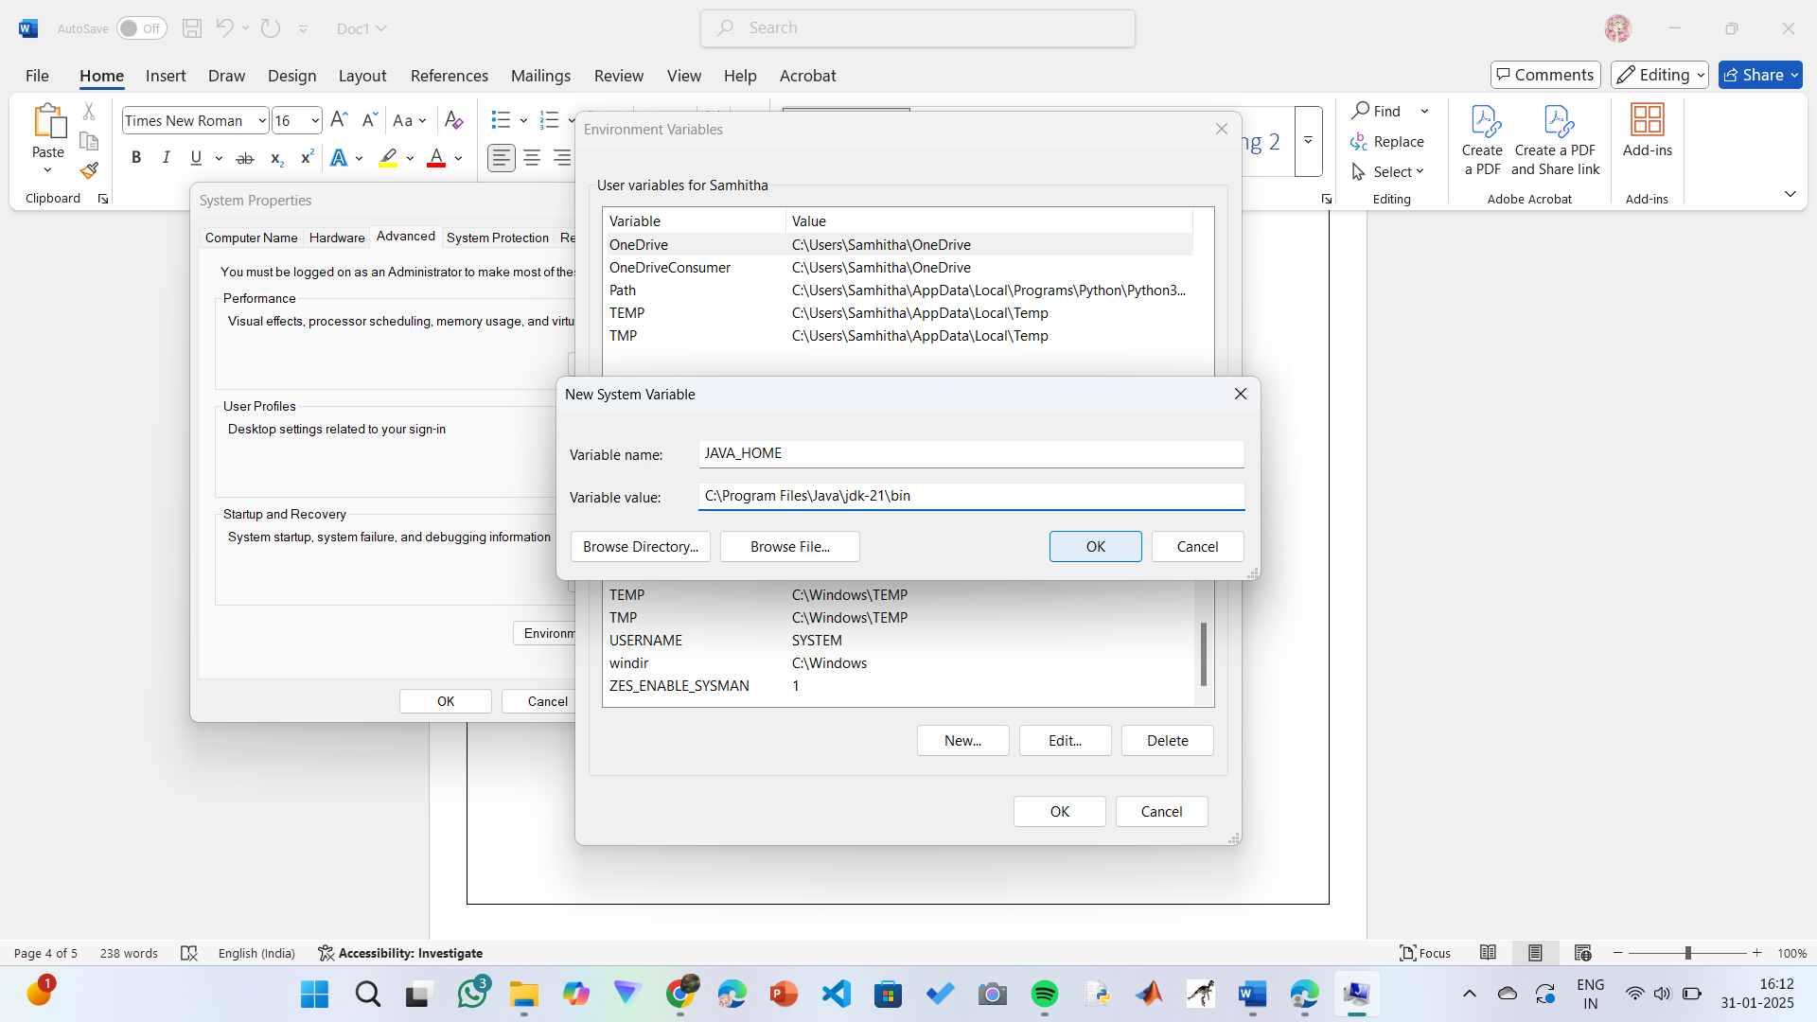

**Step 6: Update PATH Variable**

1)In System Variables, find Path and click Edit.

2)Click New and add: C:\Program Files\Java\jdk-21\bin

3)Click OK to save.

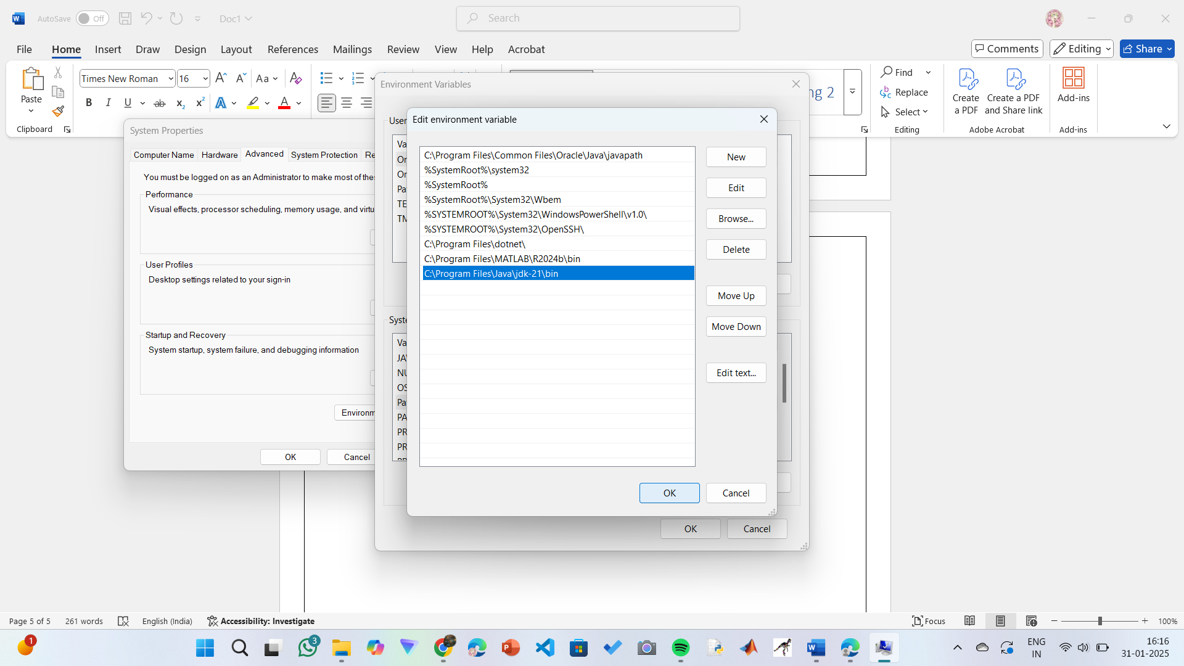

**Step 7:Verify Installation**

1. Open Command Prompt.
2. Type the following command: **java --version** and press Enter.

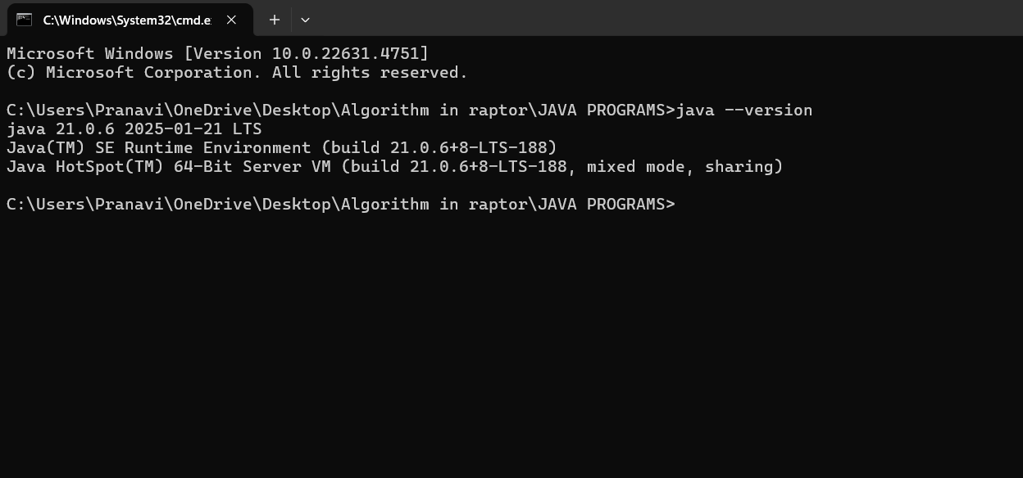

1. To check the java compiler type: **javac –version.**



**PROGRAM-2:**

**AIM:** Write a Java program to print the message “Welcome to Java Programming.”

**CODE:**

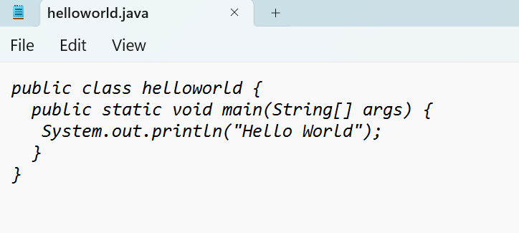

**Output:**

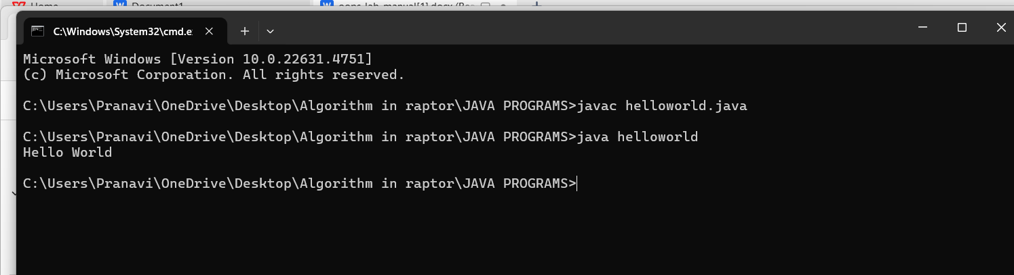

**ERRORS:** None found

**WEEK 02**

**PROGRAM-3:**

**AIM:** Write a Java Program that prints Name, Roll No, Section of a student.

**CODE:**

**STUDENT DETAILS:**

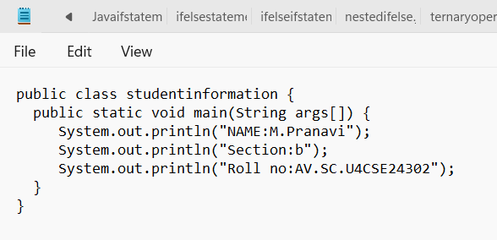

**OUTPUT:**

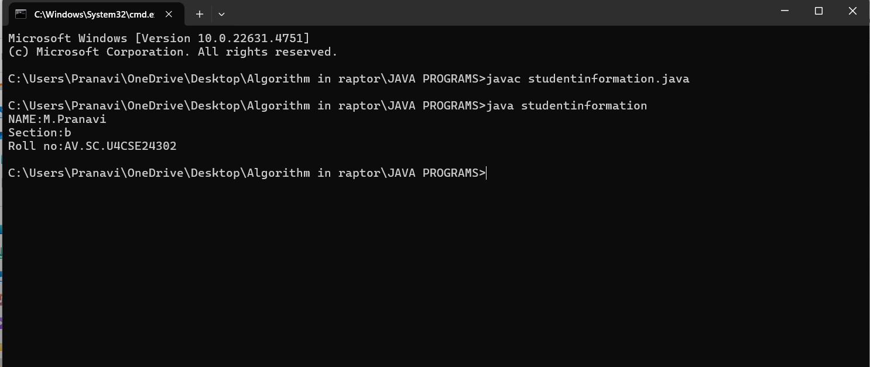

ERROR TABLE:

|  |  |
| --- | --- |
| **Code Error** | **Code rectification** |
| 1. writing small “S”in place of”S”   In system.out.println()  2)not giving strings to the name and section | 1. code is rectified by keeping capital “S” 2. Giving strings to name and section |

**PROGRAM-4:**

**AIM:** Calculate area of rectangle.

**CODE:**

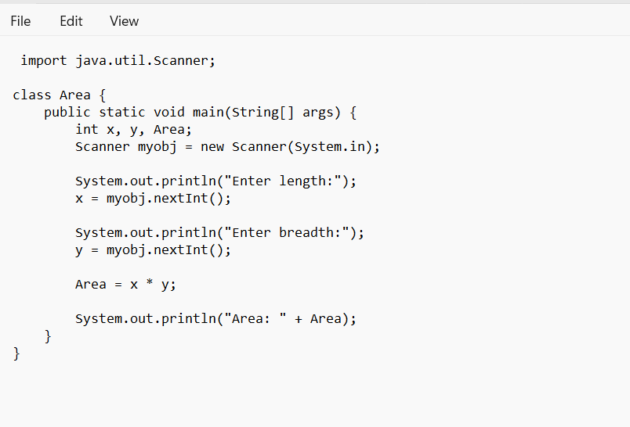

**OUTPUT:**

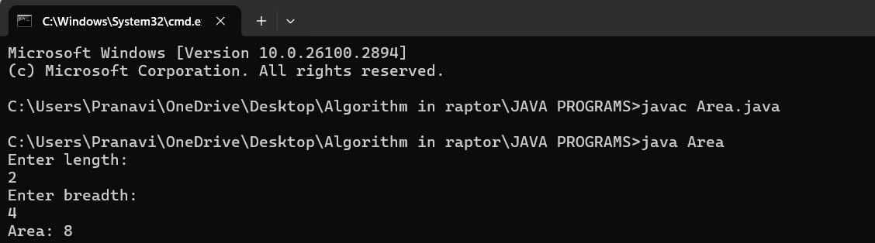

ERROR TABLE:

|  |  |
| --- | --- |
| **Code Error** | **Code rectification** |
| 1.writing small “S”in place of”S”  In system.out.println()  2.not giving strings to the name and section | 1.code is rectified by keeping capital “S”  2.Giving strings to name and section |

**PROGRAM-5:**

**AIM:**Convert temperature celsius into fahrenheit

**CODE:**

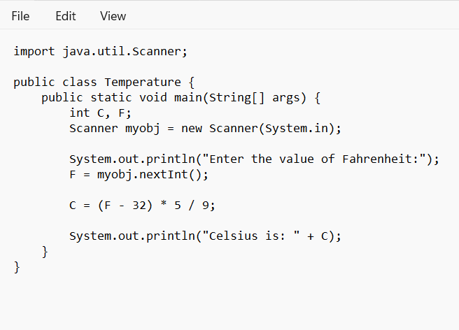

**OUTPUT:**

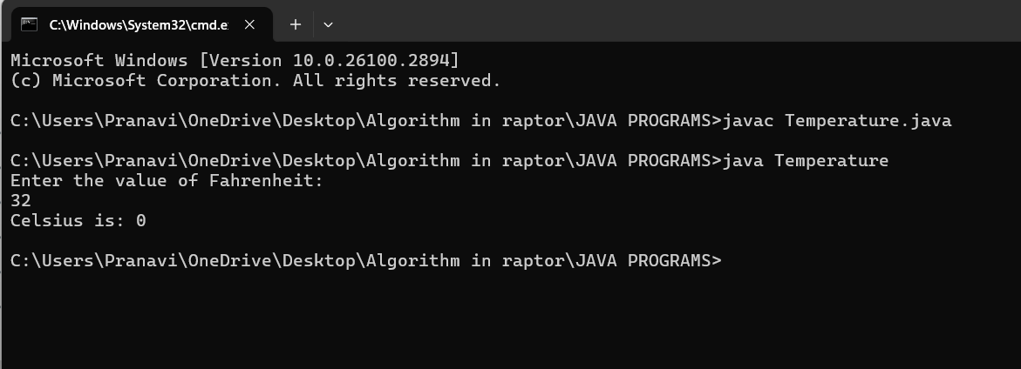ERROR TABLE:

|  |  |
| --- | --- |
| **Code Error** | **Code rectification** |
| 1.writing small “S”in place of”S”  In system.out.println()  2.not giving strings to the name and section | 1.code is rectified by keeping capital “S”  2.Giving strings to name and section |

**PROGRAM-6:**

**AIM:**Calculate the simple interest

**CODE:**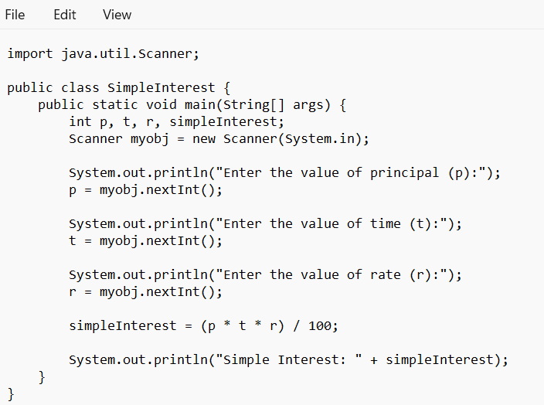

**OUTPUT:**

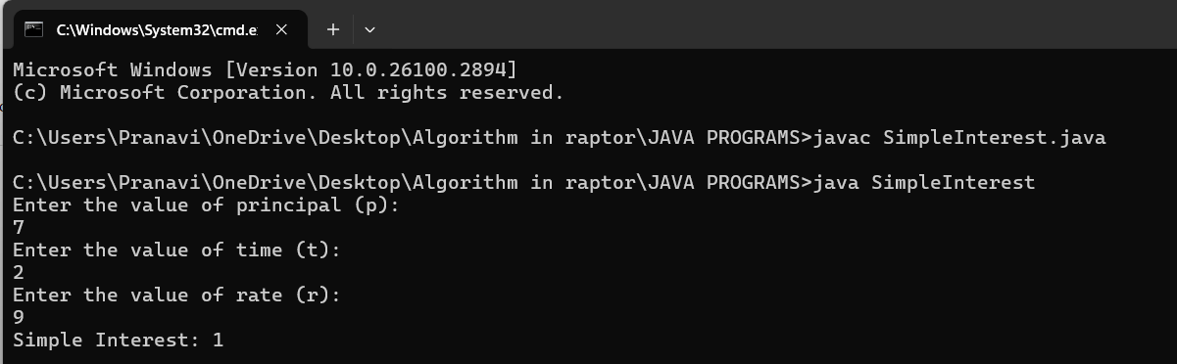

ERROR TABLE:

|  |  |
| --- | --- |
| **Code Error** | **Code rectification** |
| 1.writing small “S”in place of”S”  In system.out.println()  2.not giving strings to the name and section | 1. code is rectified by keeping capital “S” 2. Giving strings to name and section |

**PROGRAM-7:**

**AIM:**Factorial of N

**CODE:**

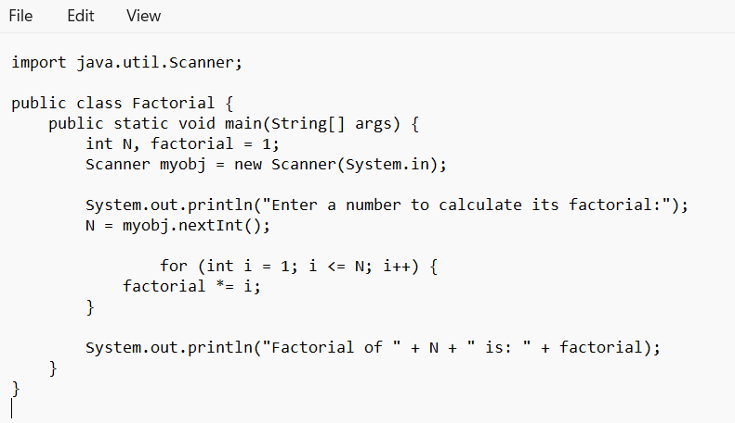

**OUTPUT:**

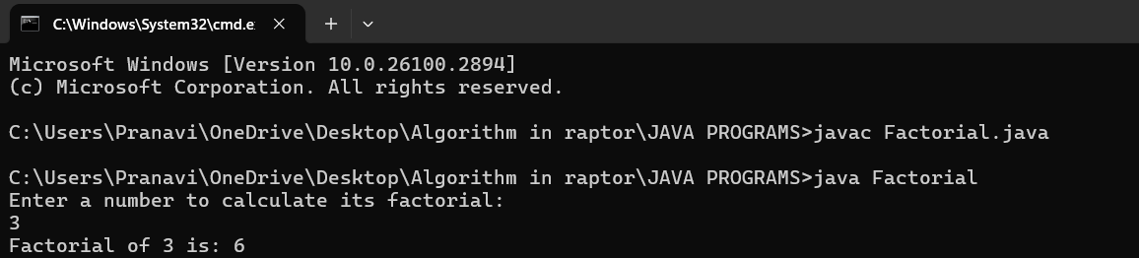

ERROR TABLE:

|  |  |
| --- | --- |
| **Code Error** | **Code rectification** |
| 1.writing small “S”in place of”S”  In system.out.println()  2.not giving strings to the name and section | 1. code is rectified by keeping capital “S” 2. Giving strings to name and section |

**PROGRAM-8:**

**AIM:**Largest of 3 numbers by ternary operators

**CODE:**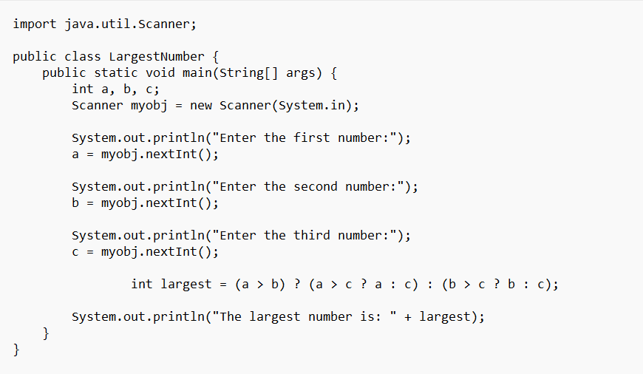

**OUTPUT:**

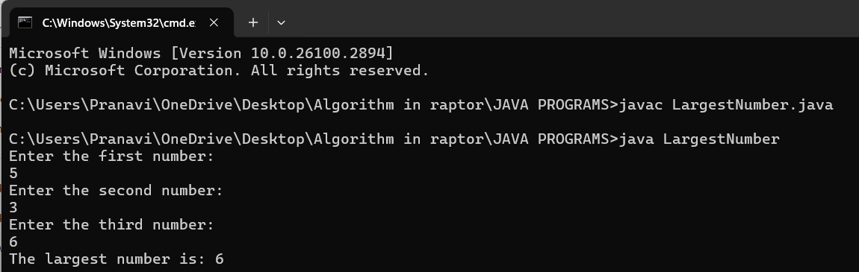

ERROR TABLE:

|  |  |
| --- | --- |
| **Code Error** | **Code rectification** |
| 1.writing small “S”in place of”S”  In system.out.println()  2.not giving strings to the name and section | 1. code is rectified by keeping capital “S” 2. Giving strings to name and section |

**WEEK 03**

**PROGRAM-9:**

**AIM:**To create java program with following instructions :

1. Create a class with name Car

2. Create four attributes named car_color, car_brand, fuel_type, mileage

3. Create these methods named start(),stop(),service()

4. Create the objects named car, car1,car2.

**CODE:**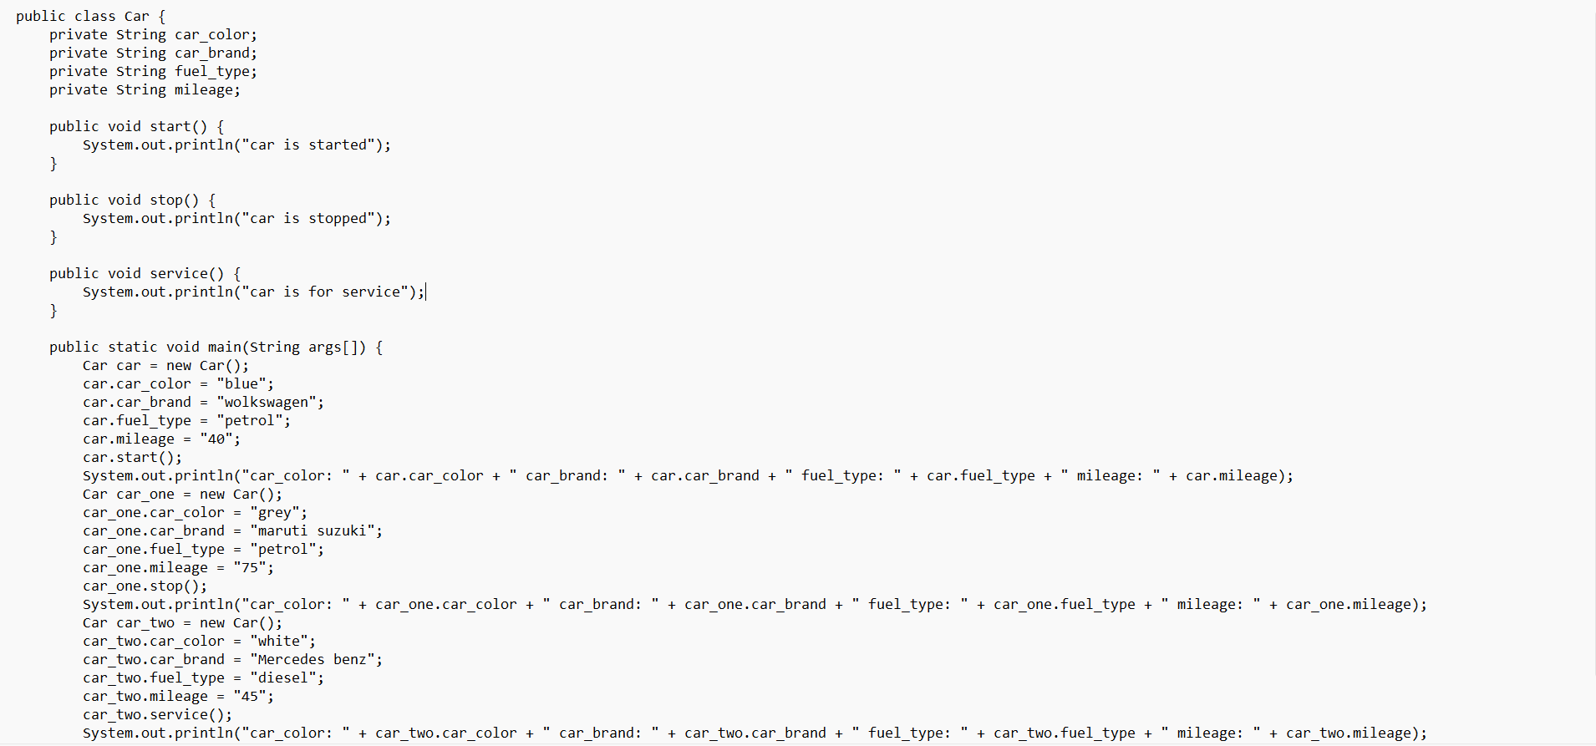

**OUTPUT:**

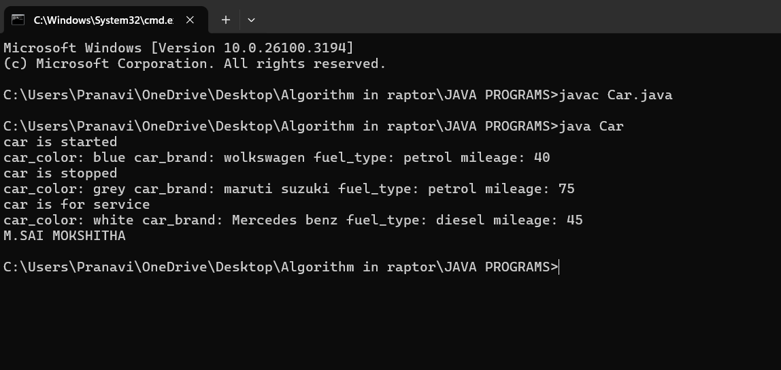

ERROR TABLE:

|  |  |
| --- | --- |
| **Code Error** | **Code rectification** |
| 1. Not putting the semi-colon; after calling the function. 2. After Start, Stop, Service not giving the parenthesis ( ). | 1. Put the semi-colon after the writing the code. 2. After every method, put the parenthesis ( ). |

IMPORTANT POINTS:

1. Before calling the function we should write the method properly.
2. Here, the “public void start( )” indicates that we are writing a method to call the function.
3. When we call a certain method, the process inside it will be printed as an output of the code.
4. Here the details inside the function are called objects, we can give any objects

**Class diagram:**

|  |
| --- |
| **car**  **-----------------------**  **-car_color:string**  **-car_brand:string**  **-fuel_type:string**  **-milage:double**  **---------------------+start():void**  **+stop():void**  **+service():void** |

**PROGRAM-10:**

**AIM:**To create a class Bank account with methods deposit() and withdraw() . create two sub classes savings account and checking account override the withdraw () method in each subclass to impose different withdrawal limits and fees.

**CODE:**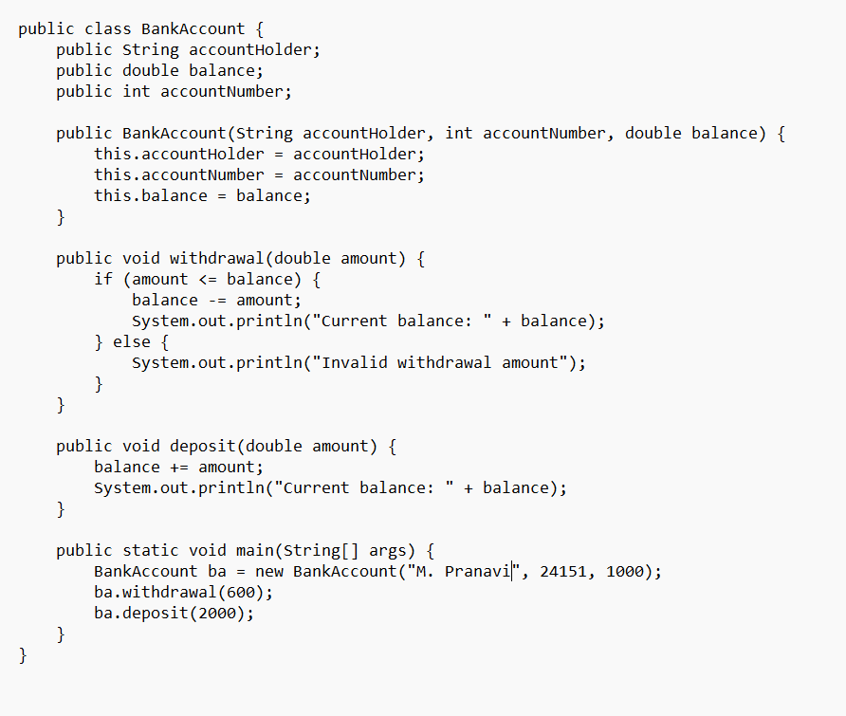

**OUTPUT:**

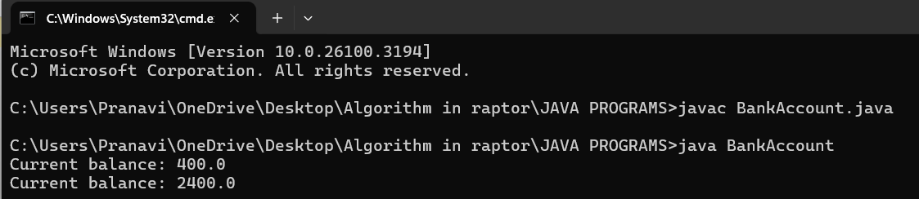

ERROR TABLE:

|  |  |
| --- | --- |
| **Code Error** | **Code rectification** |
| 1.Not putting the semi-colon; after calling the function.  2.After withdrawal, deposit not giving the parenthesis ( ). | 1.Put the semi-colon after the writing the code.  2.After every method, put the parenthesis ( ). |

IMPORTANT POINTS:

1. The condition inside the if statement must be correct.
2. It explains that if the withdrawal money is less than the money in the bank account, then we can withdraw the amount.

**Class diagram:**

|  |
| --- |
| **BankAccount**  **----------------------------------------------------------**  **-balance: double**  **----------------------------------------------------------**  **+BankAccount(intialBalance: double)**  **+deposit(amount: double):void**  **+withdraw(amount: double):void** |

**WEEK 04**

**PROGRAM-11:**

**AIM:** Write a java program with class named “book”, the class should contain various attributes such as title, author, year of publication it should also contain a constructor with parameters which initializes, title, author, and year of publication.

Create a method which displays the details of the book and display the details of two books.

**CODE:**

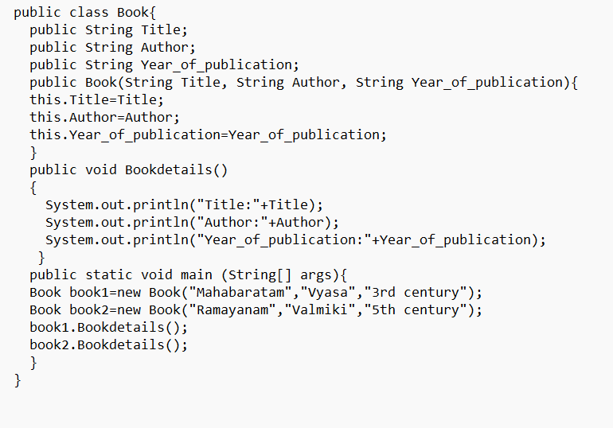

**OUTPUT:**

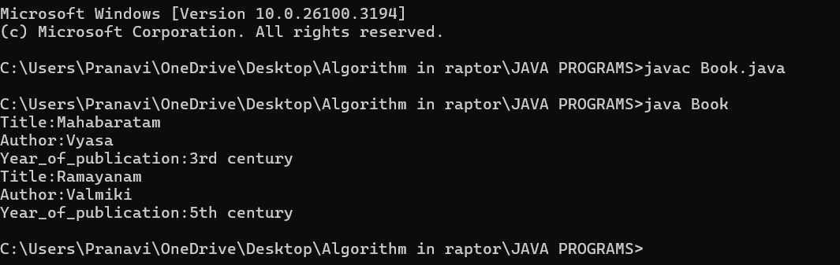

ERROR TABLE:

|  |  |
| --- | --- |
| **Code Error** | **Code rectification** |
| 1. Not defining the function in a file. 2. Two public class files should not be saved in the same file. | 1. To call the method we must define a function in a file. 2. Two public class files should be saved in different files. |

IMPORTANT POINTS:

1. While defining two classes for a code, we must be sure that we save both the classes in separate files.
2. While defining a method we should also define a function to call that method.

CLASS DIAGRAM:

|  |
| --- |
| Book   * Title: String * Author: String * Year of publication: int   + Book(title: String,  Author: String;  Year of publication: int  + displayDetails( ): void |

**PROGRAM-12:**

AIM: Create a java Program with class named myclass with static variable count of int type, initialized to zero and a constant variable “pi” of type double initialized to 3.14 as attributes of the class, ow define a constructor for “myclass” that increments the count variable each time an object of my class is created (count++), finally print the final values of count and pi variables create three objects.

**CODE:**

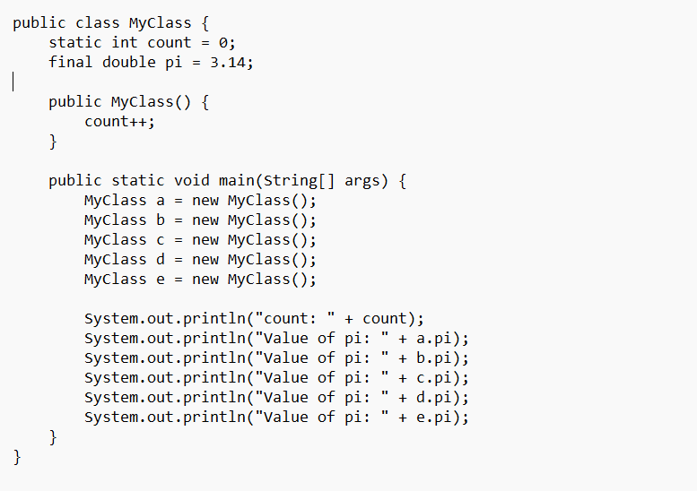

**OUTPUT:**

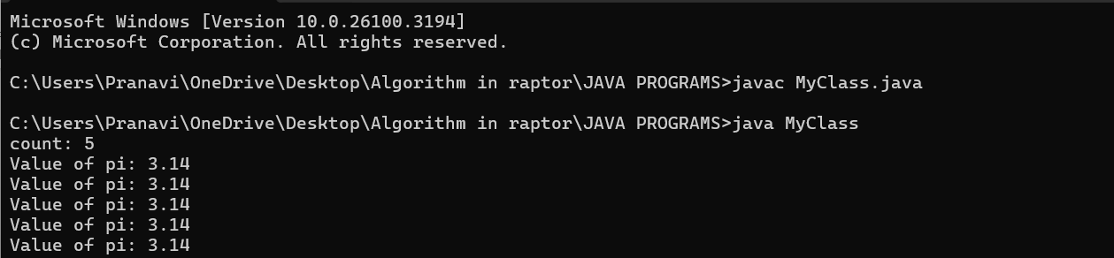

ERROR TABLE:

|  |  |
| --- | --- |
| **Code Error** | **Code rectification** |
| 1. Not Putting the semi-colon after calling a function, 2. Not giving the indentation properly. | 1. Put the semi-colon after calling a function. 2. All the indentation must be correct to run the code correct. |

IMPORTANT POINTS:

1. We must declare the initial value of the variable before declaring the final one.
2. Here the main objective is to increase the count according to the number of objects we make, i.e the count increases when the no.of objects are increasing.

CLASS DIAGRAM:

|  |
| --- |
| Myclass   * Count: int * Pi: double   + myclass( )  + main(args: String[]): void |

**WEEK 05**

**PROGRAM-13:**

AIM: Create a calculator using the operations including addition, subtraction, multiplication, and division using multi-level inheritance and display the desired output.

**CODE:**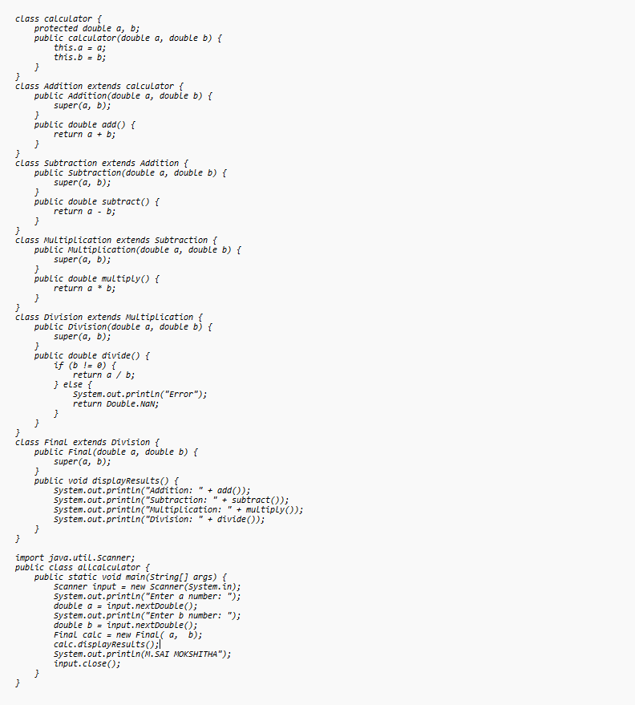

**OUTPUT:**

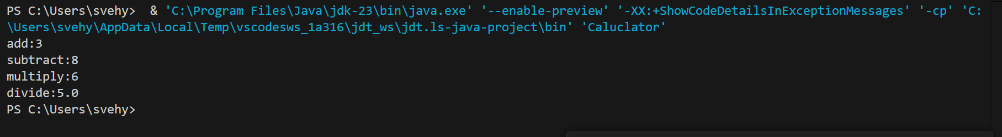

CLASS DIAGRAM:

|  |
| --- |
| Calulator   * a : double * b : double   + Calculator(a,b) |

|  |
| --- |
| Addition  + add(): double |

|  |
| --- |
| Subtraction  + subtract(): double |

|  |
| --- |
| Multiplication  +multiply(): double |

|  |
| --- |
| Division  +divide(): double |

ERROR TABLE:

|  |  |
| --- | --- |
| **Code Error** | **Code rectification** |
| 1. not providing the return method correctly. 2. Not mentioning super to obtain the super class constructor. | 1. After declaring methods, we must provide the return method correctly. 2. To obtain the super class we need to mention super. |

NEGATIVE CASE:

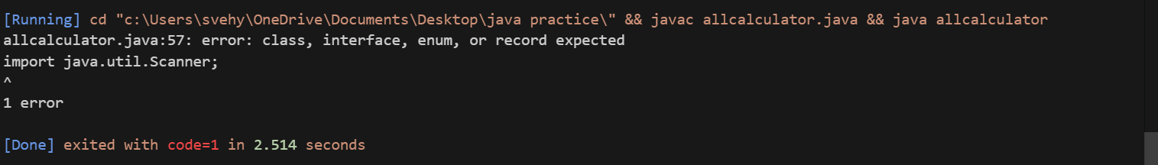

IMPORTANT POINTS:

1. To get the inputs from the user we use import java.util.Scanner; this is a package.
2. Scanner class is used to get the user input.
3. in java.util.Scanner, the java.util is a package while Scanner is a class of the java.util package.
4. to import a whole package, end the sentence with an asterisk sign(*).

**PROGRAM-14:**

AIM: A vehicle rental company wants to develop a system that maintains information about different types of vechicles available for rent the company rents out cars and bikes, and they need a program to store details about each vehicle, such as brand and speed( should be in super class)

1. cars should have an additional property: no.of doors
2. Bikes should have a property indicating whether they have gears or not.
3. The system should also include a function to display details about each vehicle and indicate when a vehicle is starting.
4. Every class should have a constructor

Question:

1. Which oops concept is used in the above program
2. If the company decides to add a new type of vehicle, Truck, how would you modify the program?
3. Truck should include an additional property capacity (in tons)
4. Create a showTruckdetails() method to display the truck’s capacity.
5. Write a constructor for Truck that initializes all properties
6. Implement the truck class and update the main method to create a Truck object and also create an object for car and bike sub classes Finally, display the details.

**CODE:**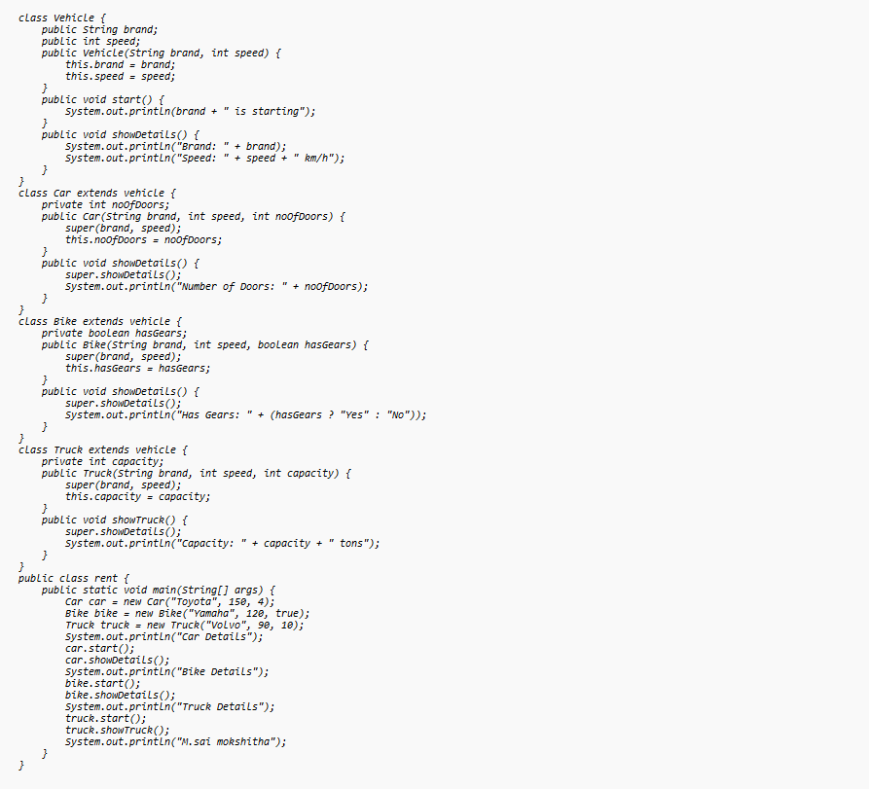

**OUTPUT:**

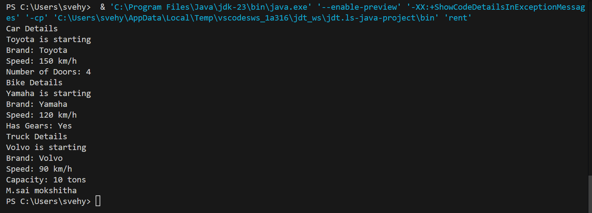

CLASS DIAGRAM:

|  |
| --- |
| Vehicle  -Brand : str  -Speed: int  + init (brand, speed)  + start_vehicle()  + display_details() |

Car Bike Truck

-

-no.of.doors: int -has gears: bool - capacity: float

+init (brand, speed +init (brand, speed displaydetails()

, no.of.doors) , has gears)

+displaydetails() +showtruckdetails()

+displaydetails()

ERROR TABLE:

|  |  |
| --- | --- |
| **Code Error** | **Code rectification** |
| 1. Declaring two superclasses inside the same file. 2. Not declaring the variable using ‘this’ keyword inside the constructor. | 1. Make two separate files to save the two super classes. 2. Declare the variable using this keyword to run the program. |

NEGATIVE CASE:

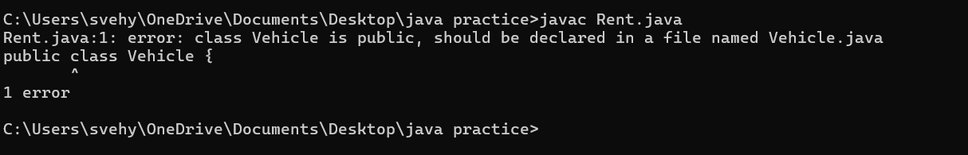

IMPORTANT POINTS:

1. a constructor helps in initializing an object that doesn't exist.
2. a method performs functions on pre-constructed or already developed objects.
3. a double method can represent more decimal point numbers than float method.
4. the void keyword in java is used to specify that a method does not return any value. it is a return type that indicates the method performs a function and doesn't produce a result.

Answer:

The oops concepts used in the above program are:

Inheritance, encapsulation, polymorphism, abstraction.

To add a new vehicle type truck we need to create a truck class that will:

* Include an additional property capacity (in tons).
* Implement a showtruckdetials() method to display the truck's capacity.
* Implement a constructor for the truck class to initialize all its properties.

**WEEK 06**

**PROGRAM-15:**Write a Java program to create a vehicle class with a method displayInfo(). Override this method in the car subclass to display specific information about a car.

**CODE:**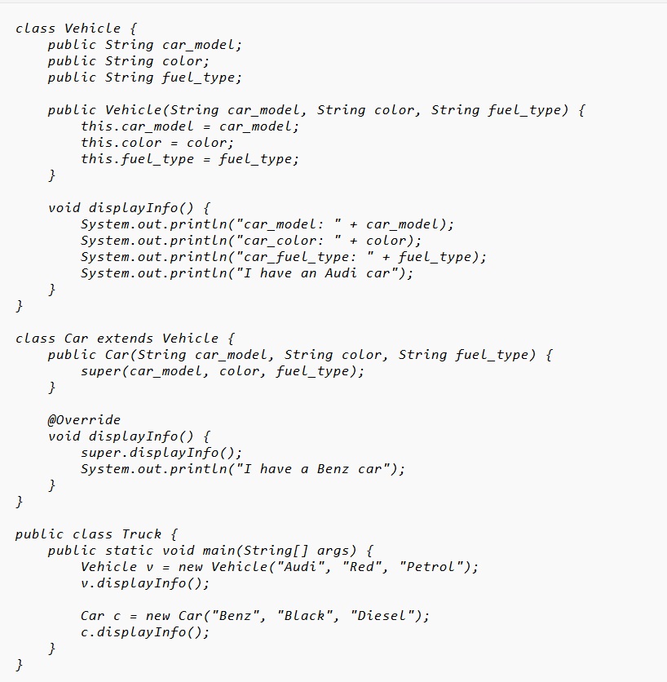

**OUTPUT:**

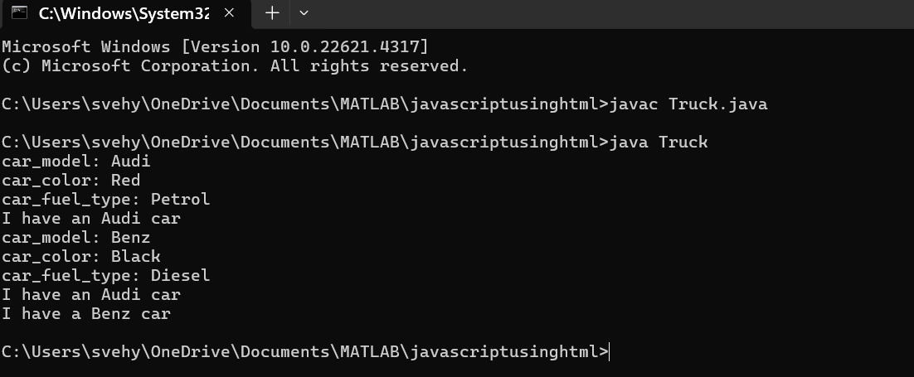

LASS DIAGRAM:

Vehicle

──────────────────────────────

- brand: String

- speed: int

├──────────────────────────────

+ Vehicle(brand: String,

speed: int)

+ startVehicle(): void

+ displayDetails(): void

ERROR TABLE:

| **Error** | **Error Rectification** |
| --- | --- |
| **1.Incorrect class name for** main **method (**Truck**)** | 1.Rename Truck to Main or place main inside Car or Vehicle. |
| **2.Inconsistent car model output in** displayInfo() | 2.Ensure Car correctlypasses  Benz" to super(car_model,  color, fuel_type);. |

Negative case:

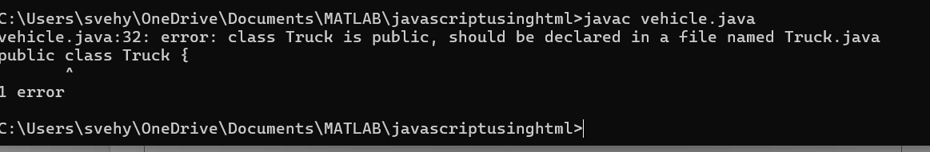

IMPORTANT POINTS:

**Inheritance:** The Car class extends the Vehicle class, demonstrating **inheritance** in Java.

**Constructor Chaining:**The Car class calls the parent constructor using super(car_model, color, fuel_type); to initialize inherited attributes.

**Method Overriding:**The Car class overrides the displayInfo() method from Vehicle and calls super.displayInfo() to reuse the parent method before adding its own output.

**Incorrect** main **Class Name:**The main method is inside Truck, which is unrelated to Vehicle and Car. The class should be renamed for clarity.

**PROGRAM-16:** Create a calculator with overloaded methods to perform addition:  
(i) Add two integers.  
(ii) Add two doubles.  
(iii) Add three integers.

**CODE:**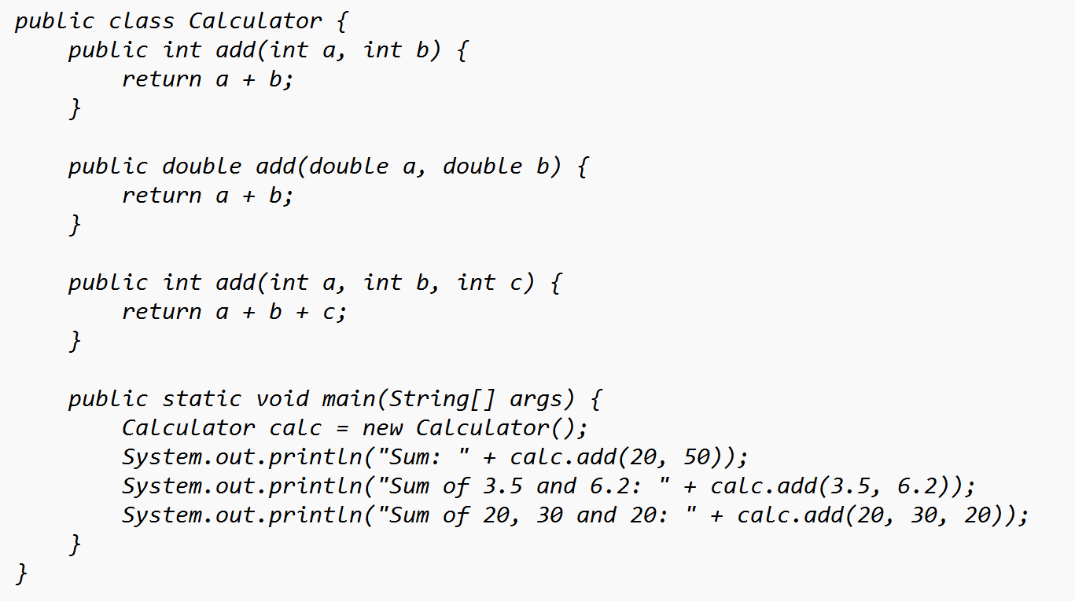

OUTPUT:

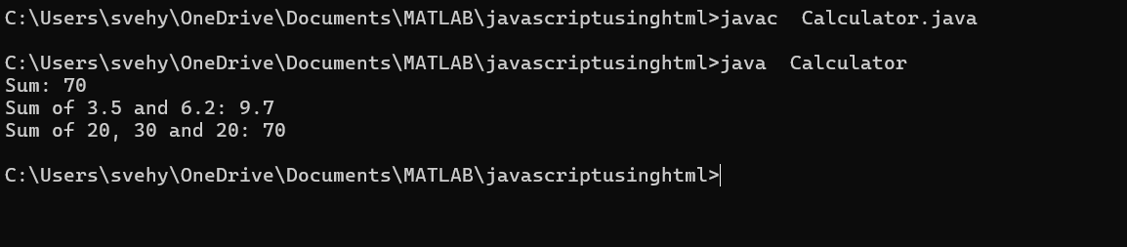

CLASS DIAGRAM:

Calculator

+add(int, int): int

+add(double, double): double

+add(int, int, int): int

+main(String[]): void

ERROR TABLE:

Code Errors CODE RECTIFICATIONS

1. Method parameters missing spaces 1.Add proper spacing between

Parameters:

(e.g., "int a,int b" should be "int a, int b") -old:add(int a,intb)

-New:add(int a,int b)

2. Inconsistent indentation in method bodies 2.Fix indentation:

(some lines not properly aligned) consist 4 space of indentation

NEGATIVE CASE:

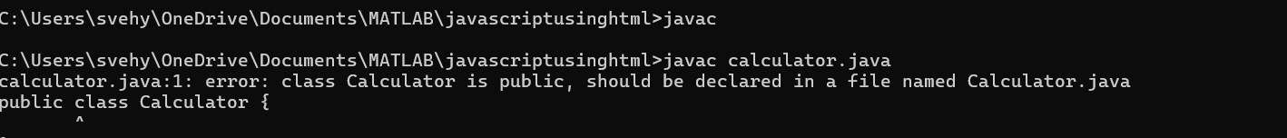

IMPORTANT POINTS:

1. **Method Overloading:** The add method is overloaded with different parameter types and counts, demonstrating compile-time polymorphism.
2. **Automatic Method Selection:** Java selects the appropriate add method based on the argument types during compilation.

**PROGRAM-17:**Create a class with a method `calculateArea()` that is overloaded for different shapes (e.g., square, rectangle). Then create a subclass `Circle` that extends this class and overrides the method to calculate the area of a circle.

**CODE:**

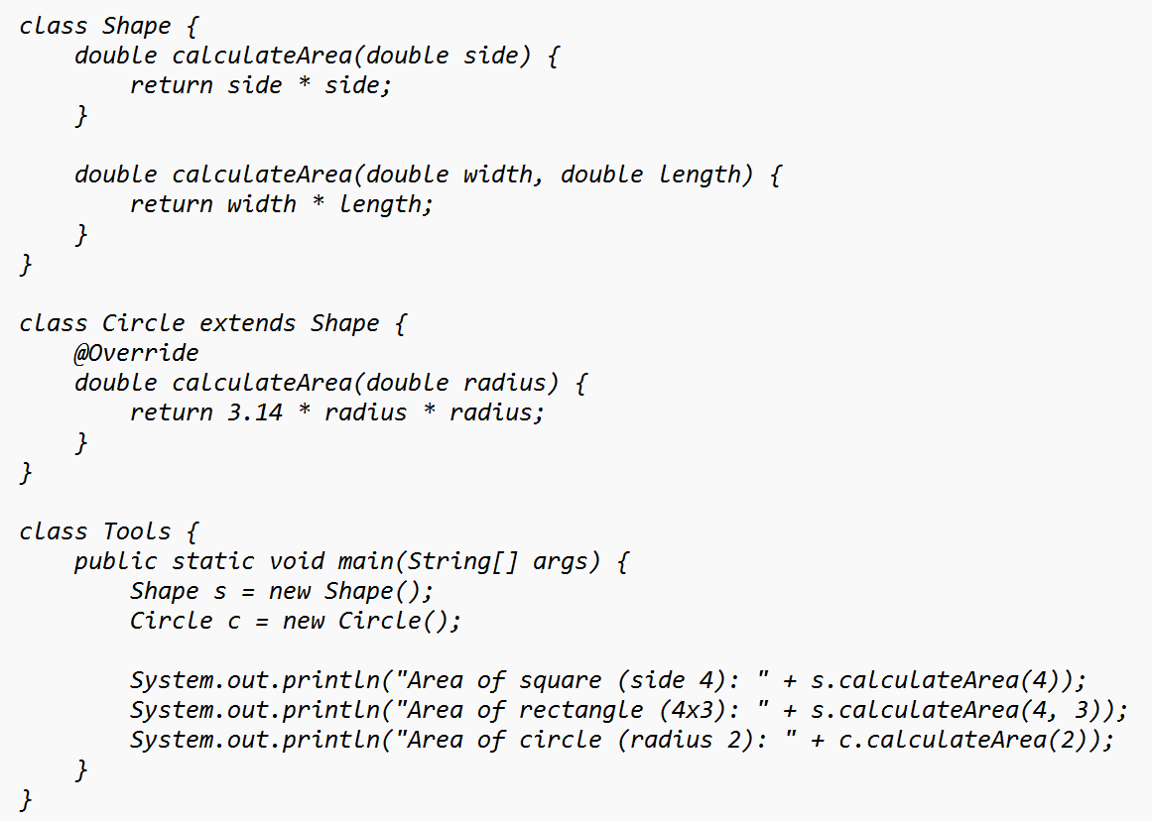

**OUTPUT:**

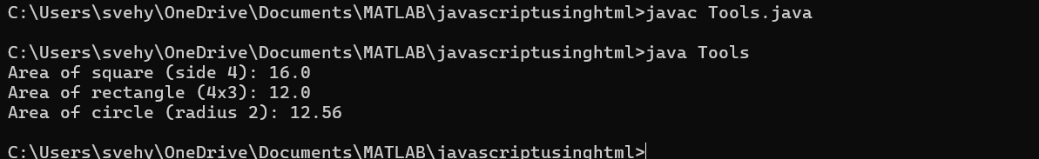

****Class Diagram****

SHAPE

+calculateArea(side: double): double

+calculateArea(width: double, length: double): double

▲

CIRCLE

+calculateArea(radius: double): double

▲

Tools

+main(args: String[]): void

### ERROR TABLE:

| **Error** | **Error Rectification** |
| --- | --- |
| 1. **Method calls in** main **are missing an 1.**   **object reference** (e.g., calculateArea(4) instead of s.calculateArea(4)). | Use s.calculateArea(4) and c.calculateArea(2) to call the method correctly. |
| **2.Circle class method does not override theparent class method properly.** | 2.Ensure @Override is used, and  the method signature should match correctly. |
|  |  |

Negative case:

### 

### **Important Points:**

**1.Inheritance**: Circle class extends Shape, inheriting its methods.

**2.Method Overloading**: Shape has multiple calculateArea methods with different parameters.

**3.Method Overriding**: Circle overrides calculateArea from Shape to implement its own formula.

**4.Polymorphism**: The overridden method in Circle demonstrates runtime polymorphism.

**5.Proper Object Reference**: Methods should be called using an object (s.calculateArea(4), c.calculateArea(2)).

**PROGRAM-18:**Create a class with a method `calculateArea()` that is overloaded for different shapes (e.g., square, rectangle). Then create a subclass `Circle` that extends this class and overrides the method to calculate the area of a circle.

**CODE:**

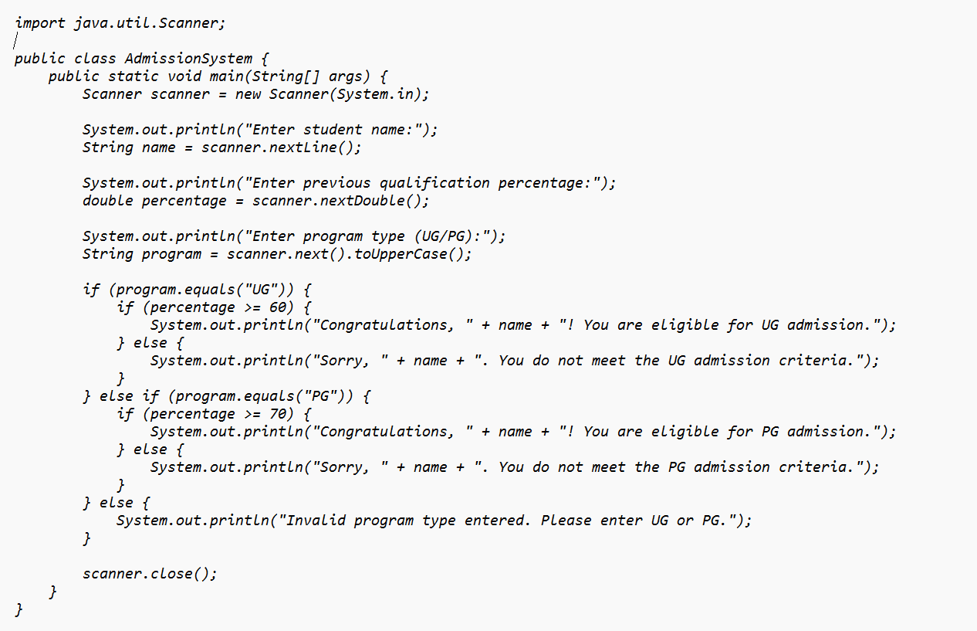

OUTPUT:

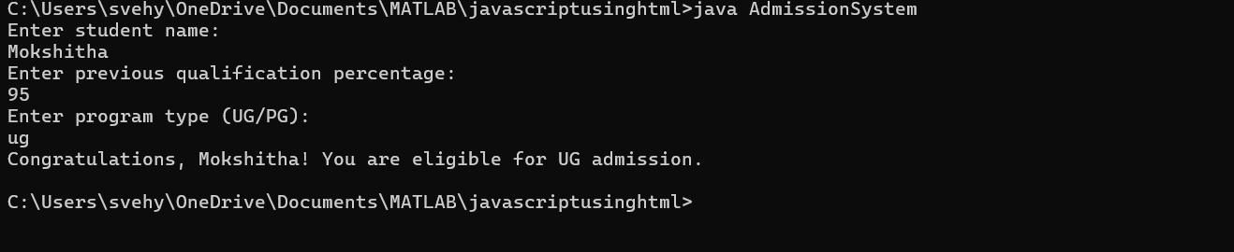

CLASS DIAGRAM:

AdmissionSystem

- scanner: Scanner

- name: String

- percentage: double

- program: String

+ main(args: String[]): void

+ takeInput(): void

+ checkEligibility(): void

+ closeScanner(): void

### ****Error Table:****

| **Error** | **Error Rectification** |
| --- | --- |
| **1.Scanner nextLine() issue after nextDouble()**: After scanner.nextDouble(), the newline character remains in the buffer, causing nextLine() to be skipped. | 1.Add scanner.nextLine(); after nextDouble(); to consume the leftover newline. |
| **2.Program type input case sensitivity issue**: If the user enters ug or pg in lowercase, it may cause incorrect comparisons. | 2.Use program.toUpperCase() to ensure case-insensitive comparison. |

NEGATIVE CASE:



### ****Important PointS:****

### ****User Input Handling****: Uses Scanner to take user input for name, percentage, and program type.

### ****Decision Making with Conditions****: Uses if-else statements to check eligibility criteria.

### ****String Handling****: Converts program input to uppercase (toUpperCase()) to handle case variations.

### ****Closing Scanner****: Properly closes scanner using scanner.close(); to prevent resource leaks.

